IE2 Report Creation User Guide



Contents

Introduction………………………………………………………………………..3
Creating a Report……………….………………………………………….…..4
Report Settings…….…………………………………………………………….5
Report Criteria…………………………………………………………………..6
Data Table – Adding & Removing Columns………………………..8
Data Table – Reordering Columns……………………………………..9
Data Table - Aggregation……………….…………………………………10
Data Table - Column Visibility…………………………………………..12
Data Table – Editing Columns…………………………………………..13
Data Table – Calculations………………….……………………………..14
Graphs……………………………………………………………………………..16
Bar, Column & Line Graphs………………………………………………17
Pie Graphs…………………………………………………………………..…..20
Results Page Layout……………………….………………….…………….22
Delete Report………………………………………………………………….24
Managing Reports List Page………………………………………….…24

Introduction

Exchange Administrators and other nominated key users who have been given ‘Create Reports’ access for an application are able to create and publish standard reports, aggregate the data and build a variety of graphical charts including Line, Bar, Pie using the aggregated results.

These reports are then available for all users of the application to generate online using their own run-time criteria where applicable.

The functionality is available on all deployments using our IE2 technology.

Any queries relating to this functionality should be directed to the helpdesk on 01926 844211 or via e-mail helpdesk@alcumusgroup.com

Creating a Report

All users of the Info Exchange application are able to run searches at any time using any field combinations.

An Exchange Administrator also has the ability to create a report and edit the report to further aggregate the data and build graphical charts.

Exchange Administrators can also allow other key users to be able to create reports without the need for full Administration access. This can be permitted on an application basis by updating the user’s profile in the appropriate application through the Administration > Applications tool.

It is recommended that the number of users able to create reports is kept to a minimum to avoid excessive numbers of reports being created or existing reports being altered unnecessarily.

To create a report, click the Reports tab, select the spanner icon in the top corner and choose the “Create new report” option.

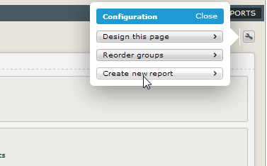

Give the report a title and select the primary table for the report and then click Continue.

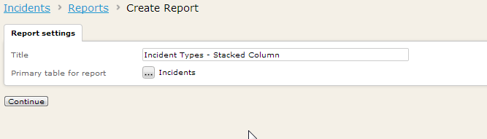

Report Settings

The following settings can be applied to a report during the initial set up and then updated at any time afterwards.

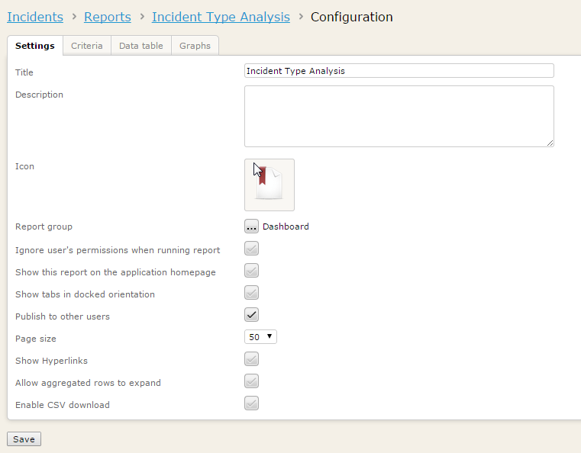

A description can be entered about the report that will appear in smaller text under the report name on the main reports page.
Select an icon from the available options to represent the report on the main reports page.

Add the report into a group - “Other reports” is the default group.

Tick to “Ignore user’s permissions when running report” if this report contains high level data only (no specific details) and it is preferable for users to report on all records not just the ones they usually have permissions to access.

Tick to “Show the report on the application homepage”. This will force the report name to appear on the application homepage in the Reports box as a hyperlink for all users. If this is not activated users will still have the ability to add it their homepage if they wish.

Tick to “Show tabs in docked orientation” to present the layout of the finished report in a docked tab format of data tables and graphs rather than stacked below each other on a single page view.

Tick the “Publish to other users” when the report is complete and is ready for other system users to access and run.
Select the “Page size” to determine the number of records to show on each page of the report data table.

Tick “Show Hyperlinks” to allow the first column of each record in the data table to be used as a hyperlink clicking through to the summary page of the record.

Tick “Aggregated rows to expand” to allow reports with aggregation to display a chevron that will expand to display all individual rows that are included in the aggregated row. Please note that activating this option can increase the page load time of a report.

Tick “Enable CSV download” to display the download csv option on a report – this will be disabled by default.

Click Save to update the report with the chosen settings.

Report Criteria

The Criteria tab of the report configuration is divided into 2 sections – Fixed and Runtime criteria.

Fixed criteria can be set up by the report creator and will be locked into the report each time it is generated with only records that match the fixed criteria values being returned.

Runtime criteria are fields that can be applied to the report as an initial page for the user running the report to decide which criteria options to choose. The report will then return records that match the user’s specified criteria values.

A combination of the 2 can be used e.g. fixed criteria of records with an “Open” Status plus a runtime criteria of a Date field so that each user running the report can vary the records retuned by the date range entered but only Open records will ever be returned in the results.

To apply either type of criteria click the “Add additional criteria” button and tick the required fields from the available fields as shown below and click Done.

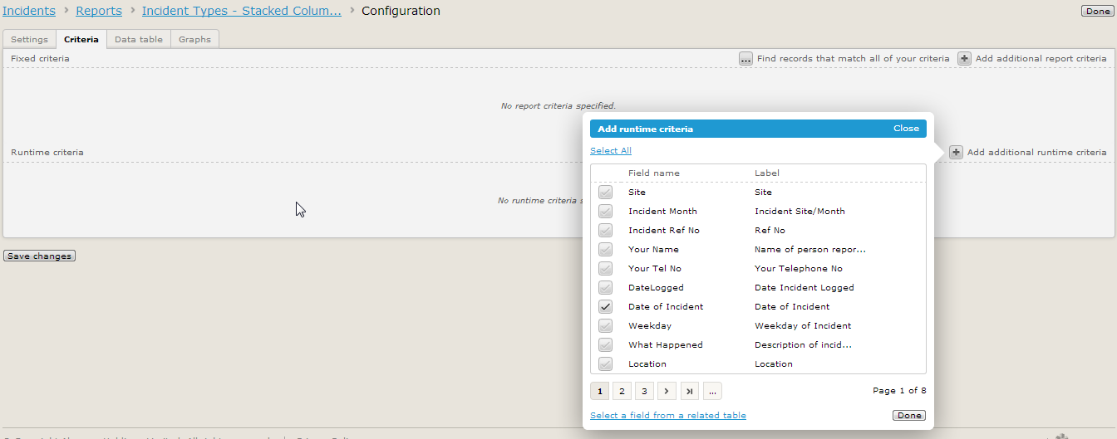

For fixed criteria, select the required values from the chosen fields and click Done.

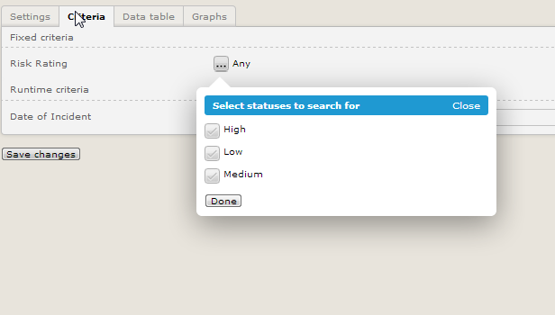

Note that fields from related tables can also be included as criteria – when selecting the required fields use the blue hyperlink at the bottom of the field selector box to select a field from a related table.

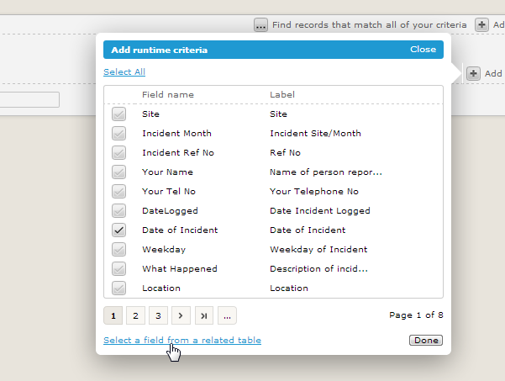

An example might be to navigate up the table hierarchy to the Site table and then tick the Region field from the list of fields in the Sites.

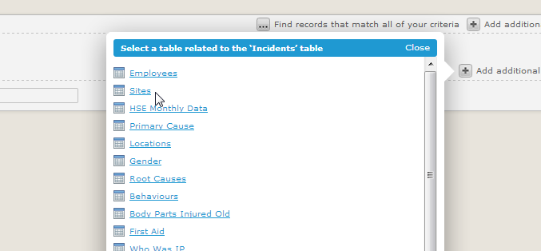

When all criteria have been applied, click the Save Changes button.

Data Table – Adding & Removing Columns

The next tab in the report configuration is the Data table and this displays the columns of data for the records that are returned in the report results.

To add or remove columns from the data table, click on the Edit Columns options on the right hand side and choose “Add or remove columns” from the menu.

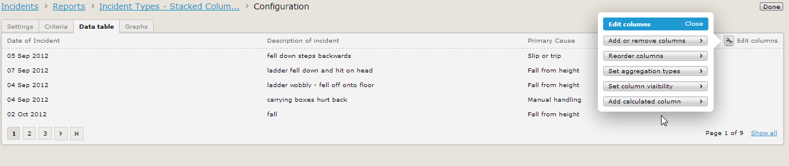

Tick or un-tick the fields that are required as columns in the data table.

Fields from related tables can also be included by using the blue hyperlink at the bottom of the window and following the same process as described in the Criteria section to navigate to other tables and tick required fields.

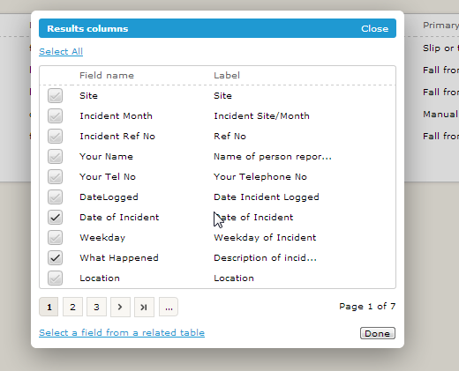

Data Table – Reorder Columns

When the required fields are displayed as columns, these can then be reordered into a preferred layout.

Note that if aggregation is going to be applied to the data, the aggregation field must be the first column in the table.

To reorder the fields, select the Edit Columns option again and choose the “Reorder columns” option from the menu.

Drag and drop each field into the appropriate order and click Done when complete.

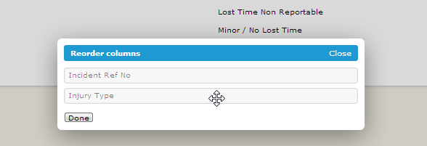

Aggregation

To aggregate records together and produce counts of the aggregated data click the 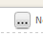icon next to the No aggregation status on the right hand side.

2 levels of aggregation are supported in the Data table.

To aggregate by the field that is the first column in the data table tick the first Aggregate option.

To aggregate at 2 levels by the fields that are the first and second columns in the data table tick the 2nd Aggregate option.

Click Done to apply the aggregation to the data table.

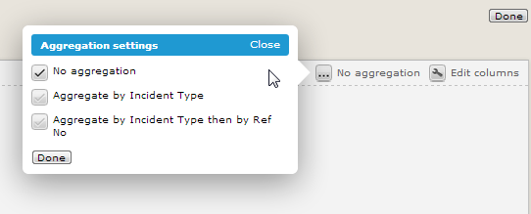

If the fields required for aggregation are not displayed as options in the Aggregation settings box, the columns in the data table need to be reordered to first and second column position. The aggregation settings box will automatically update with the new fields after the reorder has been applied.

Selecting an aggregation option will then prompt a choice of including subtotal rows.

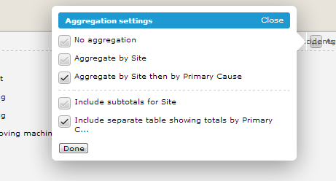

When aggregating by 2 fields there will be an option to include a 2nd table in the data table area that shows the total record count by the 2nd field in a separate table.

Table aggregated by Site and then Primary Cause

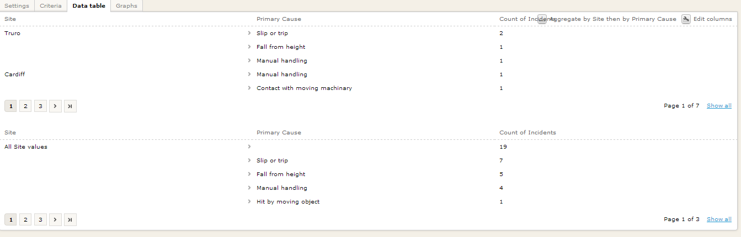

Separate table aggregated just by Primary Cause

To set the aggregation values click Edit Columns on the right hand side and select “Set aggregation types” from the menu.

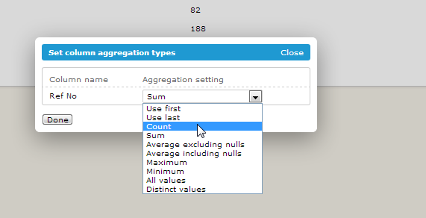

Choose the appropriate option from the list available for each column in the data table. Count or Sum are the most commonly required options. Click Done to update the data table.

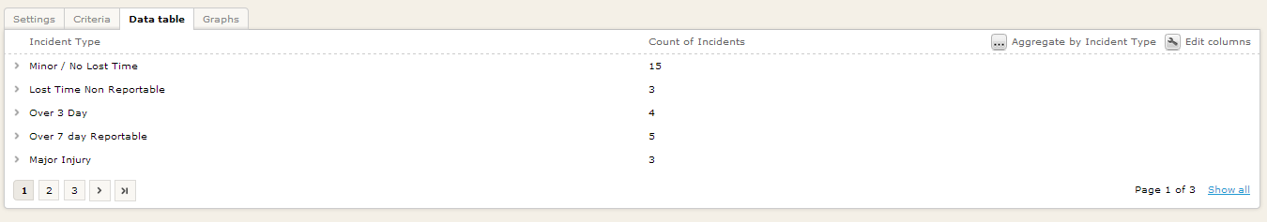
Data Table - Column Visibility

Sometimes fields have to be included in the report data table as a column for purposes such as plotting the field on a graph or including the field in a report calculation but the report creator does not actually want to show this field on the data table as a column to the users running the report.

Column visibility can be set on or off to display only the required fields on the data table.

Click the Edit Columns button on the right hand side and select “Set column visibility” from the menu option.

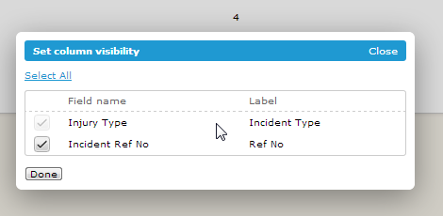

Tick or un-tick the fields to set the visibility for each column and then click Done.

Data Table – Editing Columns

Changes can be made to an individual column by clicking on a column heading to change the settings for the column.

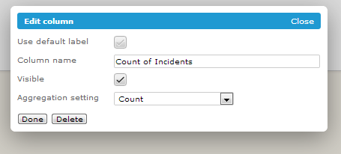
The label of the column name can be changed by un-ticking the Use default label box and typing a new Column Name into the box provided.

The column can be set to visible or not by ticking or un-ticking the box.

The aggregation setting for this column can also be updated through this interface.

Click Done to apply any updates to the data table.

Data Table – Calculations

Calculated columns can be added into the report. There are some pre-defined calculation options plus the ability to add custom calculations using any fields that are added into the data column (including non-visible fields).

To add a calculated column click the Edit Column button on the right hand side and select “Add calculated column” from the menu.

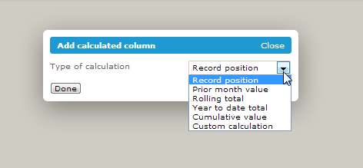

The types of calculation available will depend on the data fields included in the report, e.g. the Year to date total will only be available if there is a date field in the report table.

All of the options will present the user with some further options to complete before the calculated column is added to the report. The example below is the Rolling total calculation type:

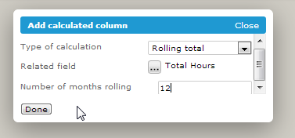

The report creator must select a related field from the fields that are used in the report (including non-visible fields) to apply the calculation to and then enter the Number of months rolling.

Click Done to update the report data table with the new calculated column.

The option for Custom calculation is more complex are there is no pre-defined calculation that will be applied and the report creator must configure the calculation using C# language.

The first stage of adding a custom calculation is to create a Name and Label for the calculated column and then choose the type of data that the column is going to display.

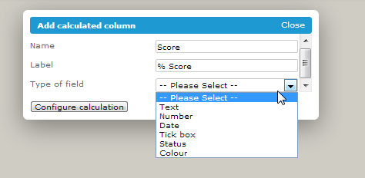

The next stage is to declare the fields that are to be used in the calculation – these must be present in the report table but can be non-visible fields.

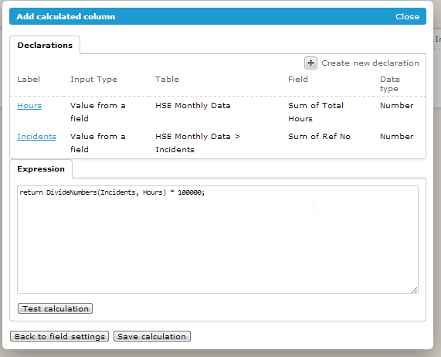

The calculation expression is then entered into the Expression box in C#.

The calculation must be tested before it can be saved.

Click Save calculation to add the new column into the report data table.
Graphs

Multiple graphs can be added to a report using the data available in the data table of the report.

To add a new graph click the Add Graph option on the right hand side and type in a Graph title.

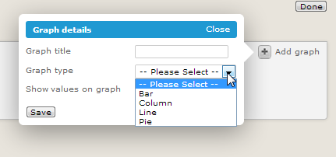

Select the type of graph and further options will then appear depending on the type chosen.

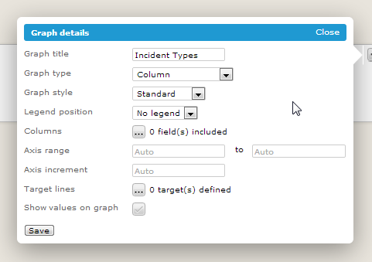

Bar, Column & Line Graphs

The options available are very similar for bar, column and line graphs.

Bar graphs display the bars horizontally across the page and Column graphs display the columns vertically up the page.



Graph Style

The Graph Style options are Standard, Sub-divided or Stacked.

Standard will display one bar, column or line in a single block colour.

Sub-divided bars and columns break a single data field into different coloured segments representing the values of the field e.g. Risk field divided into High, Medium & Low.

Stacked bars and columns stack multiple data fields onto each other in different coloured segments.

Legend Position

Choose a legend position on the graph e.g. on the Left or Right, Top or Bottom.

Fields

Select the field or fields to be plotted on the graph by ticking the required boxes.

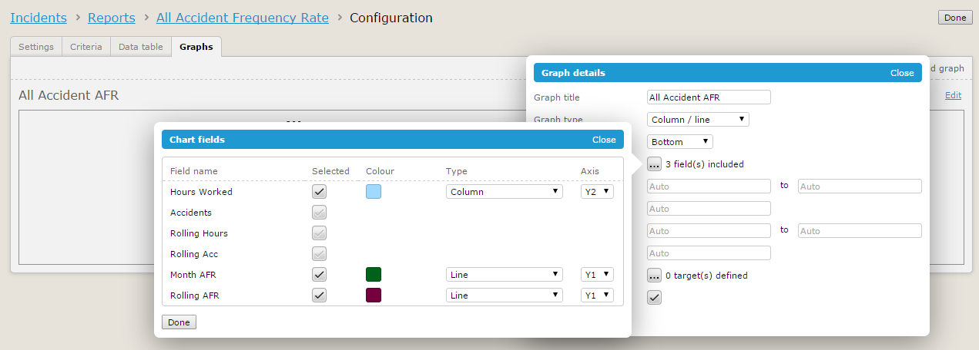

Use the Colour column to choose a specific colour for the field.

For Column and line reports choose whether the field should be plotted as a Column or a Line and then against which Y axis it should be displayed.

Axis Range & Increment

Set preferences for the Axis range e.g. 0 to 100 if the data plotted is showing percentages.

Choose a preferred Increment for the Axis e.g. increments of 100.

Column or Line graphs provide options for both Y1 and a Y2 axis.

Target Line

Add a target line onto the graph and set the value and colour of the line.
Multiple target lines can be added.

Show values on graph

Tick the box to include the data values on the graph – these will appear on top of the bar or columns or at each point of the line.

Some example bar, column and line graphs are shown on the next page.

Stacked column graph

Legend on the left

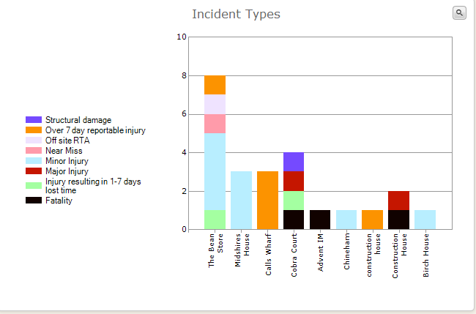

Axis range 0-10 in increments of 2.

Standard bar graph

Legend at the top

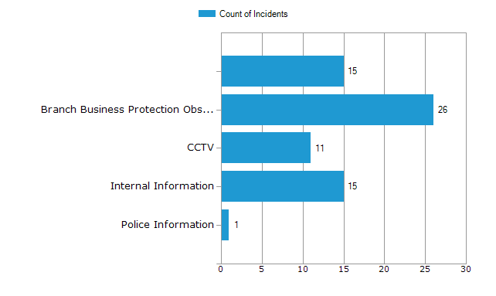

Axis increments of 5

Combined Column and Line graph

Y1 axis Y2 axis

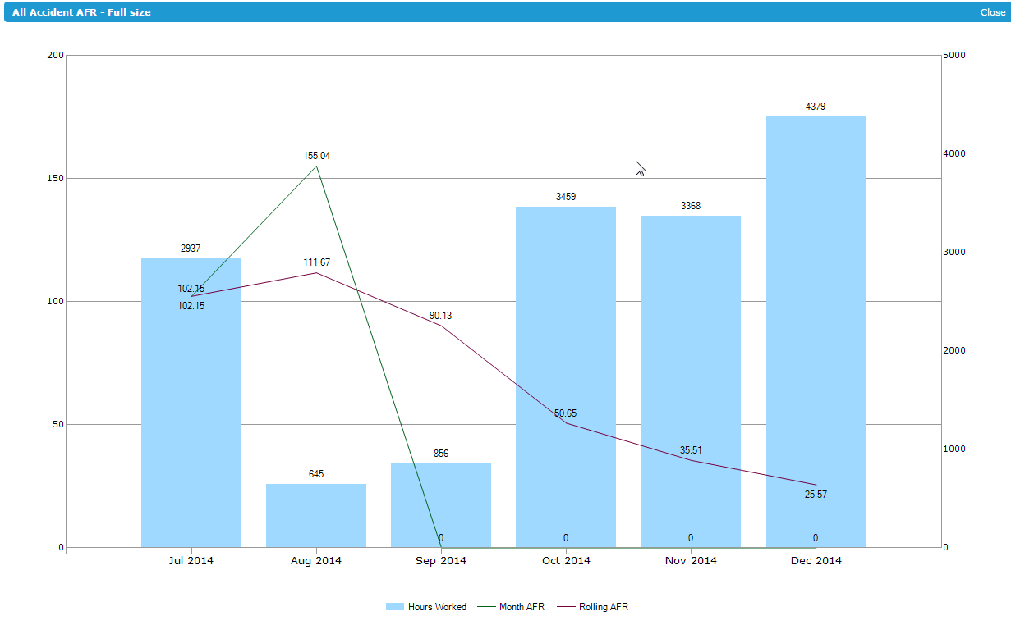

Lines and columns combined

Pie Graphs

There are fewer settings available for pie graphs as only one data field can be plotted on this type of graph.

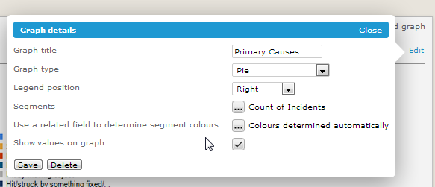

Legend Position

Choose a legend position on the graph e.g. on the Left or Right, Top or Bottom.

Segments

Choose the data field that is going to be represented in the pie by a different colour segment for each data value of the chosen field.

Segment colours

The colours of the pie graphs segments will be determined automatically by default. The report creator can choose to use a related field to determine the colours if preferred.

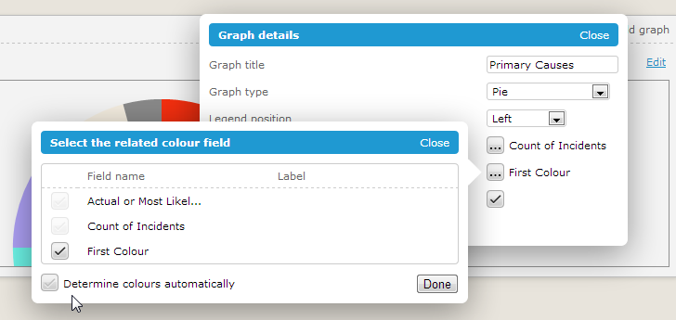

Un-tick the option at the bottom to Determine colours automatically and then tick a field that should be used to colour the segments. Only fields of a “colour” data type will be available for selection and the field can be one that is non-visible on the report data table.
Show values on graph

Tick the box to include the data values on the graph – these will in the segments of the pie.

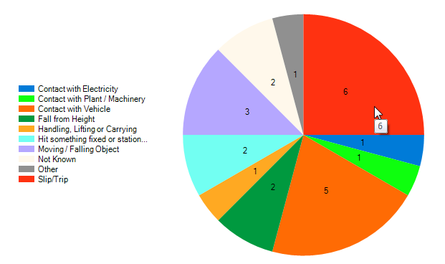

Results Page Layout

The report creator can design the layout of the report results page incorporating the data table, graphs and formatted text boxes in a variety of positions on the page.

The layout will be rendered both on screen and on the Download PDF option.

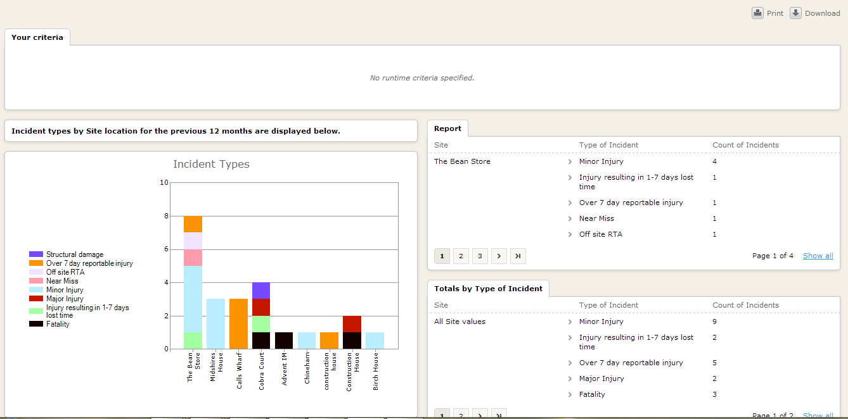

To design the page layout, click the spanner icon on the report results page and select “Design this page” from the menu.

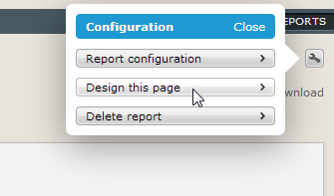

The page is divided into Segments, Columns and Objects.

Add a new segment by scrolling to the bottom of the page and clicking “Add Segment”.

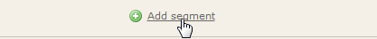

Each segment can be split into multiple columns by clicking the “Add column” button available when hovering over the right hand side of segment.

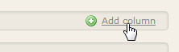

In each column, hover over the right hand side to click the “Add object” button and then select the type of object from the options shown below.

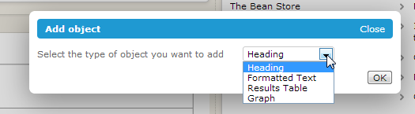

Drag and drop the objects to move around the page until the desired layout is achieved.

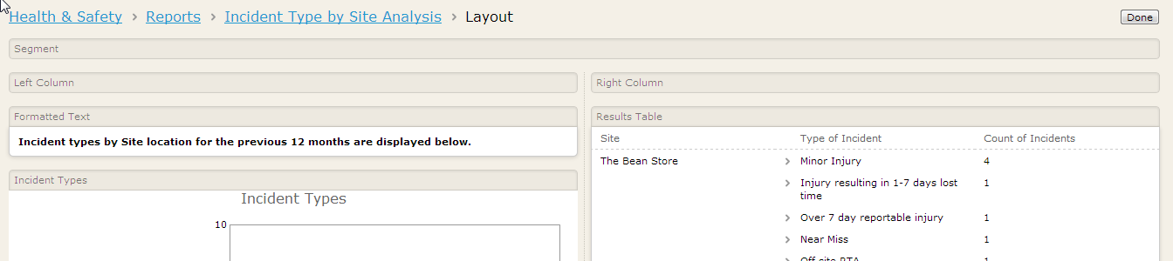

Click the Done button at the top right of the page to save the page layout design.

Deleting a Report

A report can be deleted by clicking the spanner icon on the report results page and select “Delete report” from the menu.



Managing Reports List Page

Clicking on the Report button from an application takes a user to the list of reports that are available to the user.

To manage the layout and ordering of this page, click the spanner icon from the Reports page and choose the “Design this page” option from the menu.

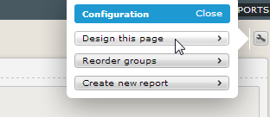

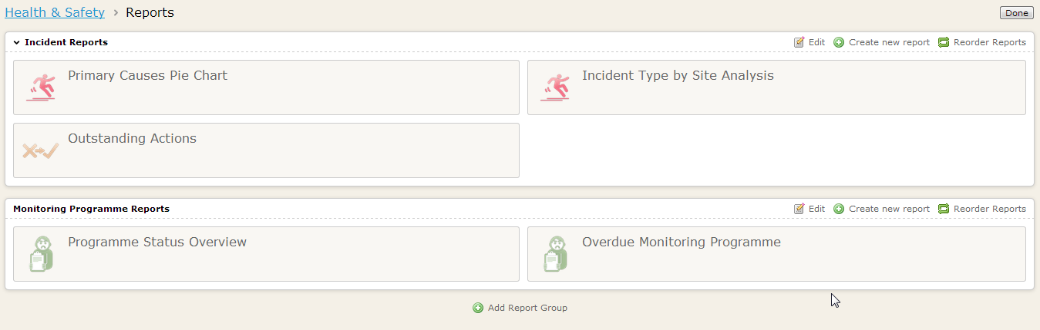

Add a new Report Group by clicking the option at the bottom of page.

Edit the name of an existing group by clicking the “Edit” button within the group.

Reorder reports within a group by clicking the “Reorder Reports” button.

Click Done at the top right of the page to save any changes made to the layout of the Report page.

